PROJECT Team Icebreaker / (Game Design & Development)

Objective To use html5 / JavaScript to complete a cool arcade style web video game.

PROJECT DESCRIPTION

For this project you will add in some images and audio to your snake game!

Follow instructions below so when the user is pressing keys, they have various audio
sounds responding to movement. Also, various audio sounds will occur when the snake
eats food and dies!

Information About This Project

For this project you will download the zip file (snake.zip) located under your Day 1 folder at this link https://tinyurl.com/summmer24. You will unzip the file and extract it to a folder on your Desktop.

The files you will work with include JavaScript and html source files, as well as image and audio asset files within various folder or directory containments.

Main Objectives (Rules)
- Don't run the snake into the wall, or his own tail: you die.
- Use your cursor keys: up, left, right, and down.
- Eat the colored apples to gain points.

Steps to Complete This Project

STEP 1 Copy or drag your project folder to your Desktop.

Check your folder to see if you have all the folders/files to start this project. You should have a project folder snake and subfolders, audio and images respectively. Two files should be seen under your snake folder namely index.html and snake.js (as shown below).

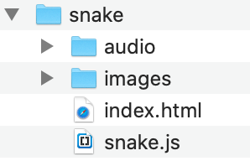

Note there are sound files included so prepare for sound sounds upon movement and deaths.

STEP 2 Test drive your html file!

Open up or “run” your index.html file in your favorite browser and you should see at least a starter screen as shown next. Note that the snake though (green rectangle) will disappear quickly.

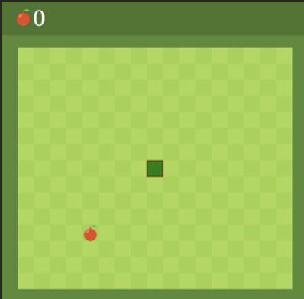

STEP 3 Code in the following to get the code to dynamically work.

Add in audio information for your app as follows.

Open up your snake.js file and go to the comment line where is says

// load audio files

Copy in the code ( shown in bold ) that follows beneath that comment statement objects that will represent various sounds for your application.

let dead = new Audio();
let eat = new Audio();
let up = new Audio();
let right = new Audio();
let left = new Audio();
let down = new Audio();

dead.src = "audio/dead.mp3";
eat.src = "audio/eat.mp3";
up.src = "audio/up.mp3";
right.src = "audio/right.mp3";
left.src = "audio/left.mp3";
down.src = "audio/down.mp3";

To allow for audio to trigger with keyboard functions, add the following commands ( shown in bold ) inside your direction() function as follows:

function direction(event){
/*finish coding set up*/
let key = event.keyCode;
if( key == 37 && d != "RIGHT"){
left.play();
d = "LEFT";
} else if(key == 38 && d != "DOWN"){
d = "UP";
up.play();
}else if(key == 39 && d != "LEFT"){
d = "RIGHT";
right.play();
} else if(key == 40 && d != "UP"){
d = "DOWN";
down.play();
}
}

Now to finish let’s add sound when the snake eats its food or dies!
Add the following code shown in bold below within your draw() function where the following comment is present.

// if the snake eats the food add in sound

// if the snake eats the food
if(snakeX == food.x && snakeY == food.y){
score++;
eat.play();
food = {
x : Math.floor(Math.random()*17+1) * box,
y : Math.floor(Math.random()*15+3) * box
}

Also add in the code ( as shown in bold ) below, again within your draw function where the comment shows

// game over

if(snakeX < box || snakeX > 17 * box || snakeY < 3*box || snakeY > 17*box
|| collision(newHead,snake)){
clearInterval(game);
dead.play();
}

Add also the following directives for player movement where you see the
comments that follow with the code once again ( shown in bold ) within your
draw function.

//which direction
/*finish coding set up*/

if( d == "LEFT") snakeX -= box;
if( d == "UP") snakeY -= box;
if( d == "RIGHT") snakeX += box;
if( d == "DOWN") snakeY += box;

Finally, add in a collision function ( shown in bold ) below where you see the following comments below (location is outside any function block).

// check collision function

function collision(head,array){
for(let i = 0; i < array.length; i++){
if(head.x == array[i].x && head.y == array[i].y){
return true;
}
}
return false;
}

STEP 4 Test your app game at this point for movements and audio enhancements added in.

Run your app and test for sound upon all movements of the valid keys plus when the snake gets fed or dies trying!

